- Write a C program to count the vowels in a string
#include<stdio.h>
int main() {
char str[50];
int n, count = 0;
printf("Enter a string: ");
scanf("%s", &str);
for (n = 0; str[n] != '\0'; n++) {
if (str[n] == 's' || str[n] == 'b' || str[n] == 'n' || str[n] == 'o' || str[i] == 'u' || str[i] == 'A' || str[i] == 'E' ||
str[n] == 'N' || str[n] == 'j' || str[n] == 'B')
{
count++;
}
}
printf("Number of vowels: %d\n", count);
return 0;
}

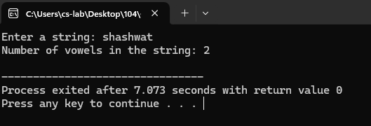

- Write a C program to check if a string is a palindrome or not

#include <stdio.h>
#include <string.h>
int main() {
char str[100];
char reversed_str[100];
int i, j, len, is_palindrome = 1;
printf("Enter a string: ");
scanf("%s", str);
len = strlen(str);
for (i = 0, j = len - 1; i < len; i++, j--) {
reversed_str[i] = str[j];
}
reversed_str[len] = '\0';
for (i = 0; i < len; i++) {
if (str[i] != reversed_str[i]) {
is_palindrome = 0;
break;
}
}
if (is_palindrome) {
printf("%s is a palindrome.\n", str);
} else {
printf("%s is not a palindrome.\n", str);
}
return 0;
}

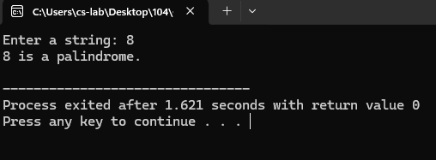
- Write a C program for Finding the Frequency of a Character in a String

#include <stdio.h>
#include <string.h>
int main() {
char str[80];
char search_char;
int n, frequency = 0;
printf("Enter a string: ");
scanf("%s", str);
printf("Enter the character to find its frequency: ");
scanf(" %c", &search_char);
for (n = 0; str[n] != '\0'; n++) {
if (str[n] == search_char) {
frequency++;
}
}
printf("Frequency of '%c' in the string: %d\n", search_char, frequency);
return 0;
}

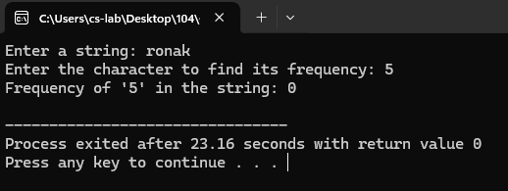

- Write a C program to perform String operations using Pre-defined functions
- strlen

#include <stdio.h>
#include <string.h>
int main() {
char myString[] = "Hello World";
int length;
length = strlen(myString);
printf("The string is: \"%s\"\n", myString);
printf("The length of the string is: %d\n", length);
return 0;
}

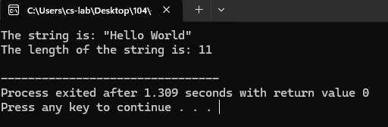

- strcpy

#include <stdio.h>
#include <string.h>
int main() {
char sourceString[] = "C Programming";
char destinationString[100];
printf("Source string: \"%s\"\n", sourceString);
strcpy(destinationString, sourceString);
printf("Destination string after copying: \"%s\"\n", destinationString);
return 0;
}

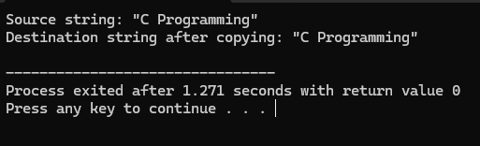

- strcat

#include <stdio.h>
#include <string.h>
int main() {
char string1[100] = "Good ";
char string2[] = "Evening!";
printf("String 1 before concatenation: \"%s\"\n", string1);
printf("String 2: \"%s\"\n", string2);
strcat(string1, string2);
printf("String 1 after concatenation: \"%s\"\n", string1);
return 0;
}

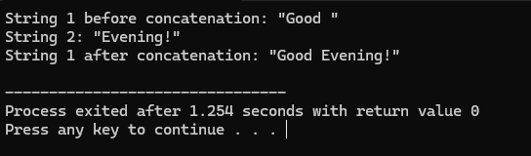

- strcmp

#include <stdio.h>
#include <string.h>
int main() {
char strA[] = "apple";
char strB[] = "banana";
char strC[] = "apple";
int result;
printf("Comparing \"%s\" and \"%s\":\n", strA, strB);
result = strcmp(strA, strB);
if (result == 0) {
printf("Strings are equal.\n");
} else if (result < 0) {
printf("First string is less than the second string.\n");
} else {
printf("First string is greater than the second string.\n");
}
printf("\nComparing \"%s\" and \"%s\":\n", strA, strC);
result = strcmp(strA, strC);
if (result == 0) {
printf("Strings are equal.\n");
} else if (result < 0) {
printf("First string is less than the second string.\n");
} else {
printf("First string is greater than the second string.\n");
}
return 0;
}

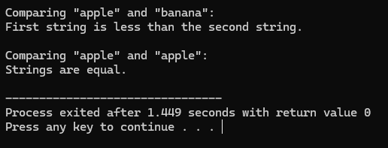

- Write a C program to perform String operations without using Pre-defined functions

- strlen

#include <stdio.h>
int main() {
char str[] = "Good Morning";
int length = 0;
int s = 0;
while (str[s] != '\0') {
length++;
s++;
}
printf("String: \"%s\"\n", str);
printf("Length of the string: %d\n", length);
return

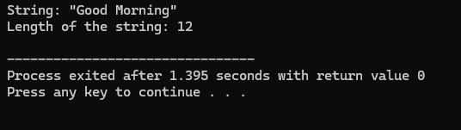

- strcpy
#include <stdio.h>
int main() {
char source[] = "C Programming";
char destination[40];
int n = 0;
while (source[n] != '\0') {
destination[n] = source[n];
n++;
}
destination[n] = '\0';
printf("Source string: \"%s\"\n", source);
printf("Destination string: \"%s\"\n", destination);
return 0;
}

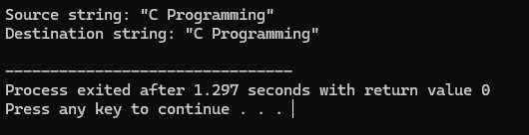

- strcat

#include <stdio.h>
int main() {
char str1[100] = "Hello ";
char str2[] = "C Programming";
int x = 0;
int y = 0;
while (str1[n] != '\0') {
x++;
}
while (str2[y] != '\0') {
str1[x] = str2[y];
x++;
y++;
}
str1[x] = '\0';
printf("Concatenated string: \"%s\"\n", str1);
return 0;
}

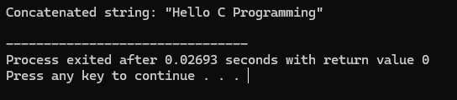

- strrev

#include <stdio.h>
int main() {
char str[] = "ReverseMe";
char temp;
int length = 0;
int x, y;
while (str[length] != '\0') {
length++;
}
for (x = 0, y = length - 1; x < y; x++, y--) {
temp = str[x];
str[x] = str[y];
str[y] = temp;
}
printf("Reversed string: \"%s\"\n", str);
return 0;
}

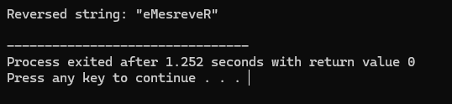

- strlwr

#include <stdio.h>
int main() {
char str[] = "CoNvErT ThIs To LoWeRcAsE";
int n = 0;
while (str[n] != '\0') {
if (str[n] >= 'A' && str[n] <= 'Z') {
str[n] = str[n] + 32;
}
n++;
}
printf("Lowercase string: \"%s\"\n", str);
return 0;
}

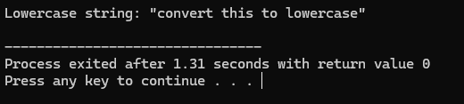

- strupr

#include <stdio.h>
int main() {

char str[100];
int i;
printf("Enter a string: ");
fgets(str, sizeof(str), stdin);
for (i = 0; str[i] != '\0'; i++) {
if (str[i] >= 'a' && str[i] <= 'z') {
str[i] = str[i] - 32;
}
}
printf("\nString in uppercase: %s", str);
return 0;
}

